
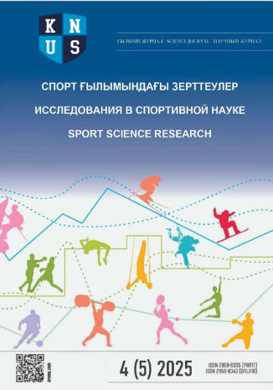
KAZAKH NATIONAL UNIVERSITY OF SPORTS

Scientific journal
“Sport Science Research”

REVIEW REPORT
Article title: “………”

Reviewer: Full name, academic degree, academic title (if any)

Criteria | Compliance with requirements |  |  | Comments
Criteria | High | Medium | Low
Relevance to the research field  “Physical  Culture and Sport” | Mark as appropriate |  |  | Provide comments
Alignment of the  article topic with  the scope of  the journal |  |  |  | Provide comments
Academic  level of the article |  |  |  | Provide comments
Scientific  novelty |  |  |  | Provide comments
Theoretical and (or) practical significance |  |  |  | Provide comments
Mandatory  (recommended)  revisions | Provide detailed comments
Reviewer’s  recommendation | Accept  (accept  with editorial  revisions) |  | Revisions  required |  | Resubmit  for another round  of review | Reject
Reviewer’s  recommendation | Mark as appropriate and comment

Date:

Reviewer _____________ Full name
(signature)

Requirements for the content of the review
The review must contain a qualified analysis of the article, an objective and well-reasoned assessment of it, and clearly substantiated recommendations.
The review should pay particular attention to the following points:
Analysis of the relevance of the topic and of the academic level of the article.
Correspondence of the content of the article to its title.
Assessment of whether the article is ready for publication in terms of language and style, and of its compliance with the established requirements for the presentation of materials.
Scholarly rigour of the presentation, and the correspondence of the methods, techniques, recommendations and research results used by the author to current advances in the field.
Adequacy and reasonableness of the length of the article as a whole and of its individual elements (text, illustrative material, bibliographic references).
Appropriateness of including illustrative material in the article and its relevance to the subject presented.
The place of the reviewed manuscript in the existing literature: whether it duplicates the work of other authors or previously published works by the same author (in whole or in part).
The reviewer’s comments and suggestions must be objective and substantive, aimed at raising the academic level of the manuscript.
The concluding part of the review must contain substantiated conclusions about the article as a whole and a clear, unambiguous recommendation as to whether or not its publication is advisable, or comments enabling the author to make corrections.

